|  |  |  |  |
| --- | --- | --- | --- |
| **Name of Student: NINAD AVINASH PATIL** | | | |
| **Roll No: 33** | | **Lab Practical Number: 1. B** | |
| **Title of Lab Practical: Write a program to implement Advanced Windows forms controls.** | | | |
| **DOP: 24/02/2021** | | **DOS: 03/03/2021** | |
| **CO Mapped: CO1** | **PO Mapped: PO3, PO5, PO7,**  **PO12, PSO1, PSO2** | **Faculty Signature:** | **Marks:** |

**Practical No 1.B**

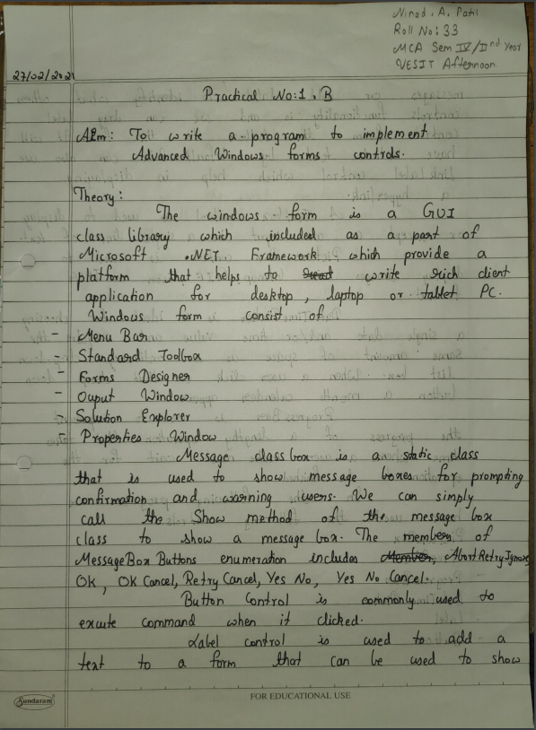

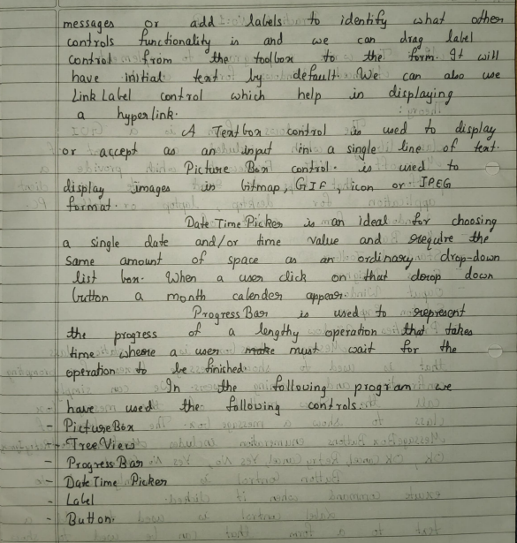

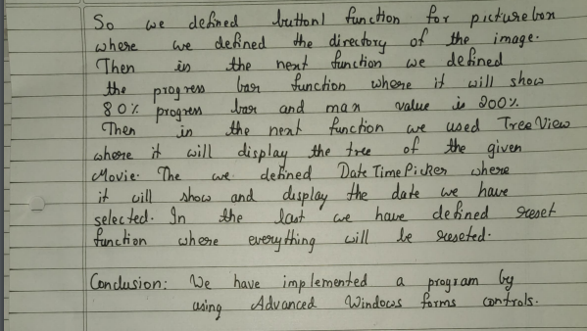

**Code:**

using System;

using System.Collections.Generic;

using System.ComponentModel;

using System.Data;

using System.Drawing;

using System.Linq;

using System.Text;

using System.Windows.Forms;

namespace WindowsFormsApplication6

{

public partial class Form1 : Form

{

public Form1()

{

InitializeComponent();

}

private void button1_Click(object sender, EventArgs e)

{

Image i = Image.FromFile("C:\\Users\\Ninad\\Documents\\Visual Studio 2010\\Projects\\WindowsFormsApplication6\\marvel.jpg");

pictureBox1.Image = i;

}

private void button2_Click(object sender, EventArgs e)

{

progressBar1.Minimum = 0;

progressBar1.Maximum = 200;

for (int i = 0; i <= 80; i++)

{

progressBar1.Value = i;

}

}

private void button3_Click(object sender, EventArgs e)

{

TreeNode node = treeView1.Nodes.Add("first", "Marvel Cinematic Universe");

TreeNode subnode1 = node.Nodes.Add("second", "Marvel Movies");

TreeNode subnode2 = node.Nodes.Add("third", "Marvel Webseries");

subnode1.Nodes.Add("CA", "Captain America - Civil War");

subnode1.Nodes.Add("IRON", "Iron Man 3");

subnode1.Nodes.Add("AV", "Avengers: End Game");

subnode2.Nodes.Add("WV", "Wanda Vision");

subnode2.Nodes.Add("LOKI", "Loki");

subnode2.Nodes.Add("FW", "The Falcon And The Winter Soldier");

}

private void button4_Click(object sender, EventArgs e)

{

label2.Visible = true;

label2.Text = dateTimePicker1.Text;

}

private void button5_Click(object sender, EventArgs e)

{

pictureBox1.Image = null;

progressBar1.Value = 0;

treeView1.Nodes.Clear();

label2.Visible = false;

}

}

}

**Output:**

